

**Empowering Women,**

**while preserving Nature.**



**Experience the Future of Menstrual Care with Bio-Pads offered by:**



**Your Partner in Sustainable Menstrual Hygiene Management**



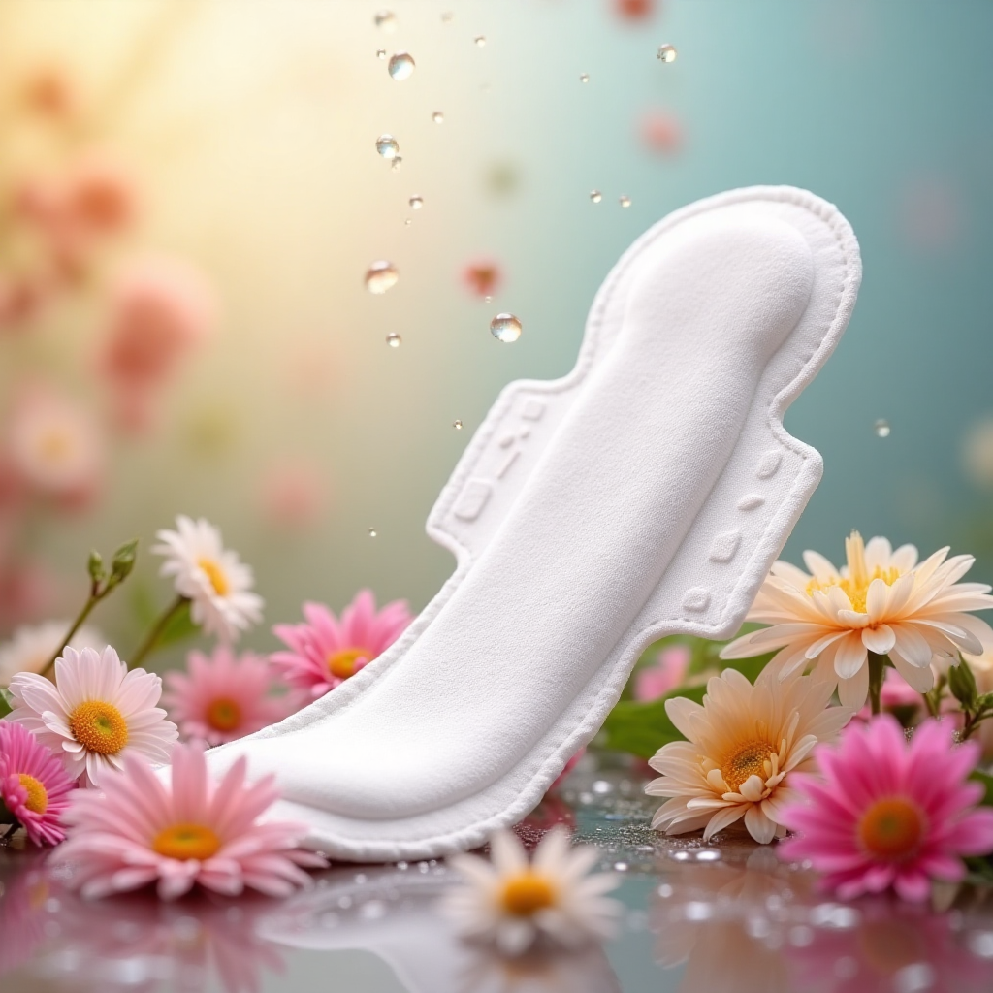

At Saba Care Africa, in techno-commercial collaboration with The Green Mantra International Limited, we believe every woman deserves a period that is not only comfortable and confident but also kind to our precious planet. Introducing "Happy Periods" BIO PAD – a revolutionary step in menstrual hygiene management that blends superior performance with uncompromising environmental responsibility.

**The Challenge & Our Solution:**

**The Urgent Need: Combating Plastic Pollution**



**Problem Statement:**

* 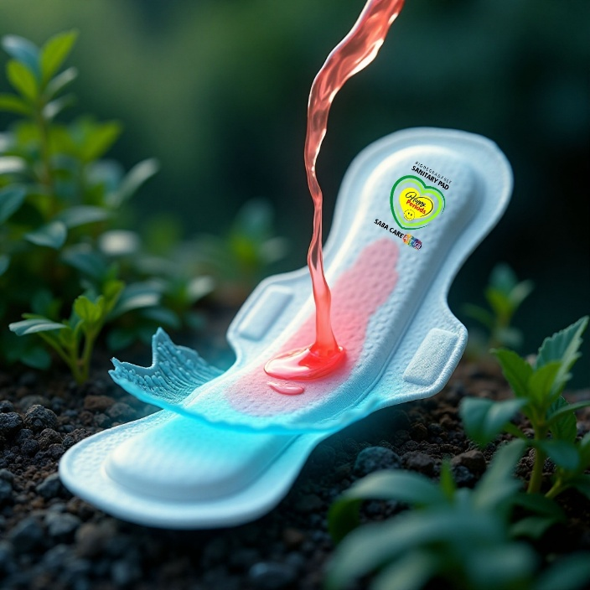Health concerns associated with synthetic materials.
* Conventional sanitary pads contribute significantly to plastic waste.
* Environmental burden: takes hundreds of years to decompose.

**Our Solution: Bio Pads**

* Biodegradable & Compostable Sanitary Pads.
* Designed for maximum comfort and superior performance.
* A conscious choice for women and the environment.

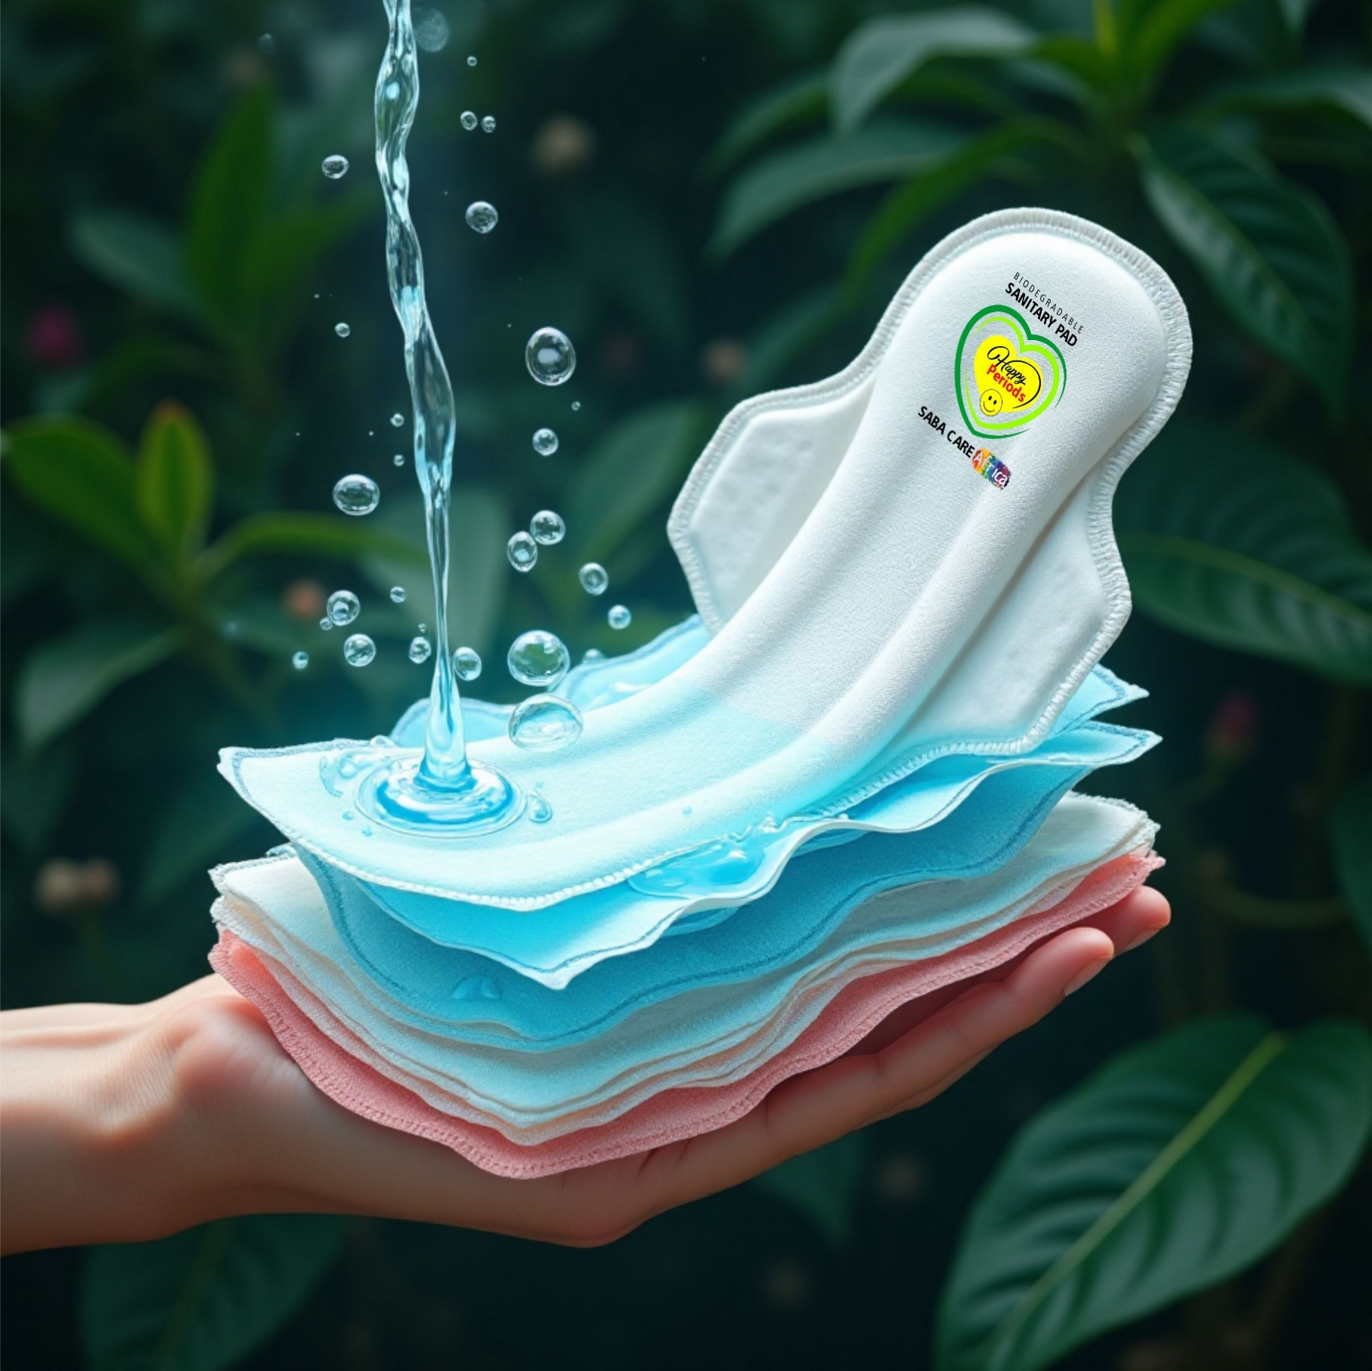**Unmatched Performance:**

**Super Absorption & Lasting Comfort**



**Designed for Confidence – No Leaks, All Day Protection**

* Utilizes advanced absorbent materials
* Ensures quick liquid intake and secure retention

**Super Absorption Capability**

Designed with advanced natural absorbent materials, our Bio Pads rapidly lock away fluid, ensuring long-lasting dryness and leak-free confidence throughout your day. **Stay active, stay worry-free!**

**Long-Lasting Comfort.**

**Gentle on Skin, Gentle on Earth:**



**Experience ultimate softness and breathability.**

Bio Pads are crafted from gentle, irritation-free materials that conform to your body, providing unparalleled comfort and a fresh feeling, even during extended wear.

* Soft, breathable, and irritation-free materials.
* Ergonomically designed for a perfect fit.
* Provides a feeling of freshness and dryness throughout the day.

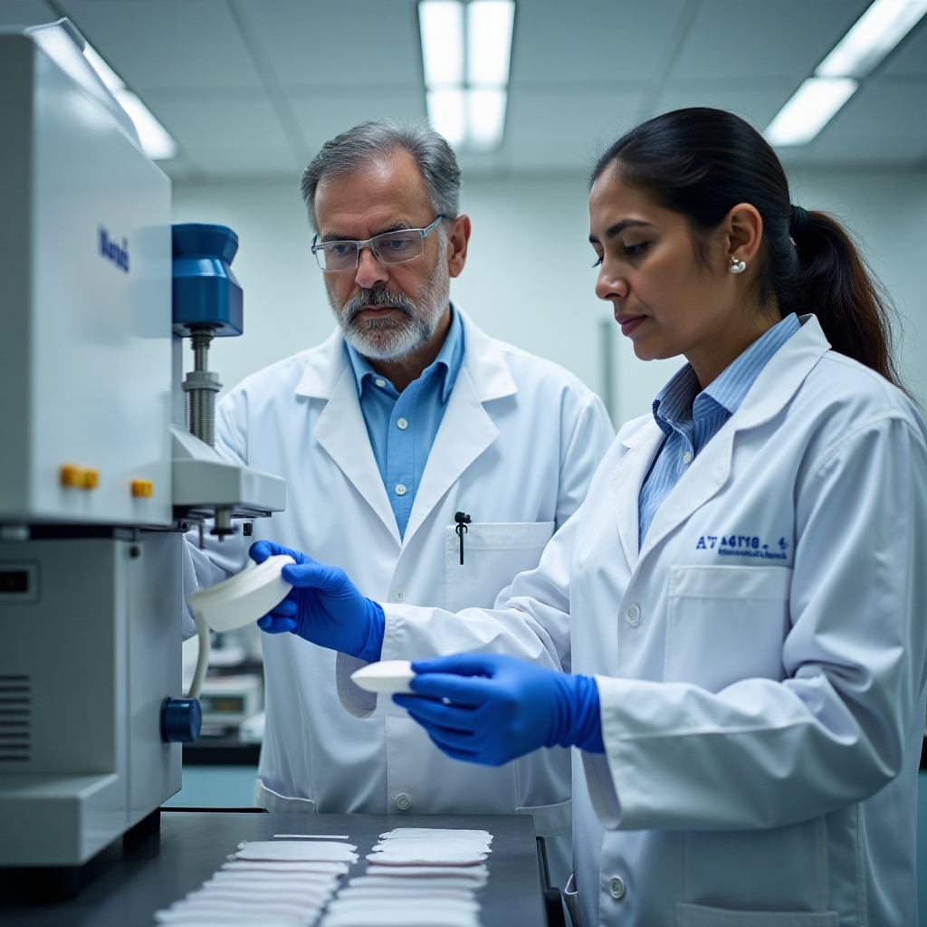**Certification Behind "Bio Pad"**

**Rigorously Tested,**

**Universally Trusted.**



**Accredited Lab Testing:** Be assured of the highest standards; Bio Pads are rigorously tested by NABL accredited Labs, adhering to relevant ISO standards for technical properties, material integrity, and complete safety.

**Technical Properties & Material:** Ensuring structural integrity, strength, and consistency.

**Ecotoxicity Studies:** Verifying no harmful effects on the environment during decomposition.

**Safety:** Dermatologically tested, free from harmful chemicals and irritants.

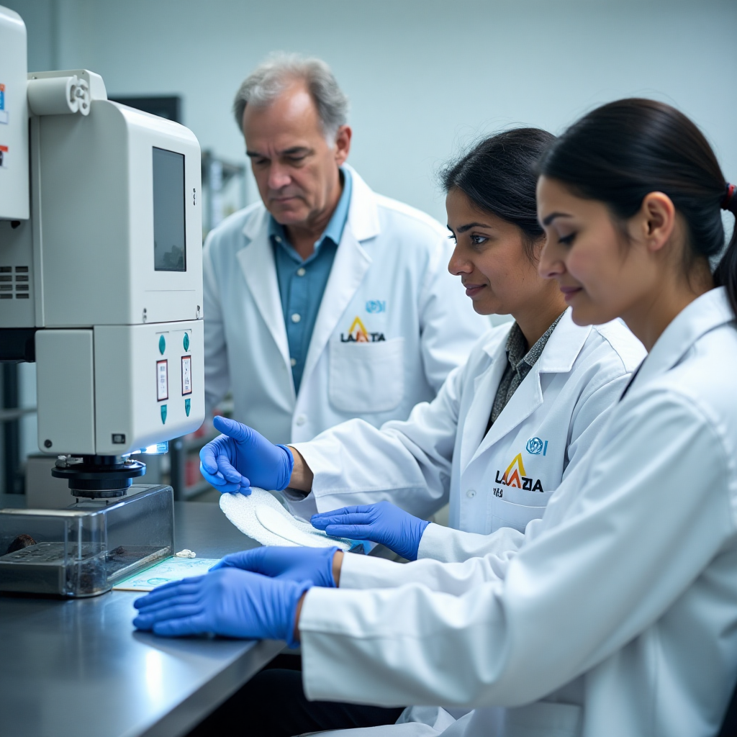



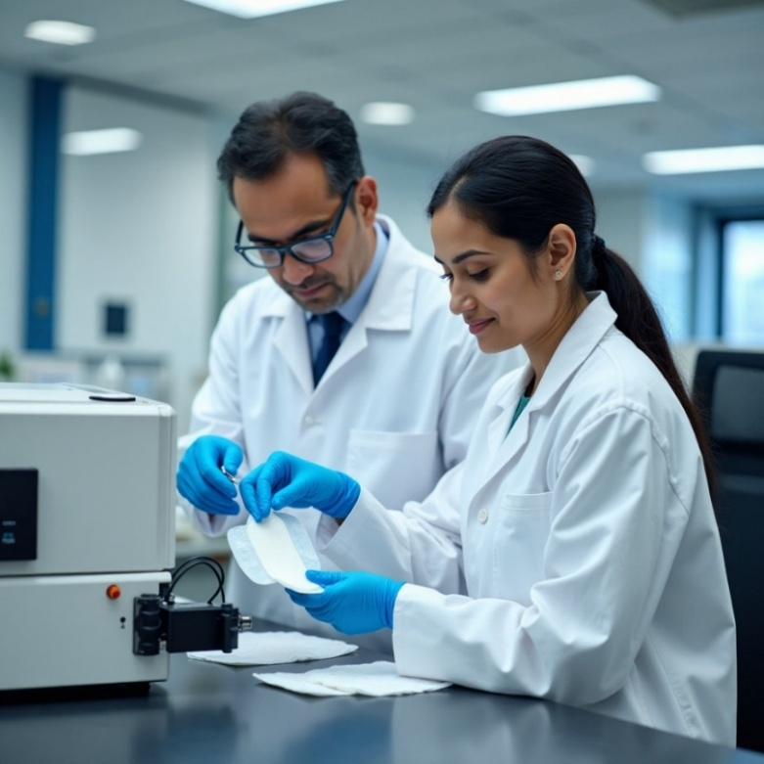**Certified Compostable Material:**

BIO PADs are crafted from materials certified to ISO 17088 standards, ensuring that these pads will completely compost, seamlessly integrating back into the environment and nourishing the soil.

Ensuring a thorough transformation into natural components under composting conditions serves as evidence of true compostability, going beyond mere biodegradability.

**Health Benefits:**

**Because Your Well-being Matters:**



**Gentle on Skin:** Free from harmful chemicals and synthetic irritants often found in conventional pads, our biodegradable materials reduce the risk of rashes, allergies, and discomfort.

**Promotes Hygiene:** Designed for superior absorption and breathability, our pads help maintain optimal intimate hygiene, contributing to your overall reproductive health and well-being.

**Dignified Menstrual Hygiene:** Providing access to high-quality, safe, and comfortable pads empowers women and girls, fostering dignity and enabling full participation in daily life, free from period-related anxieties.

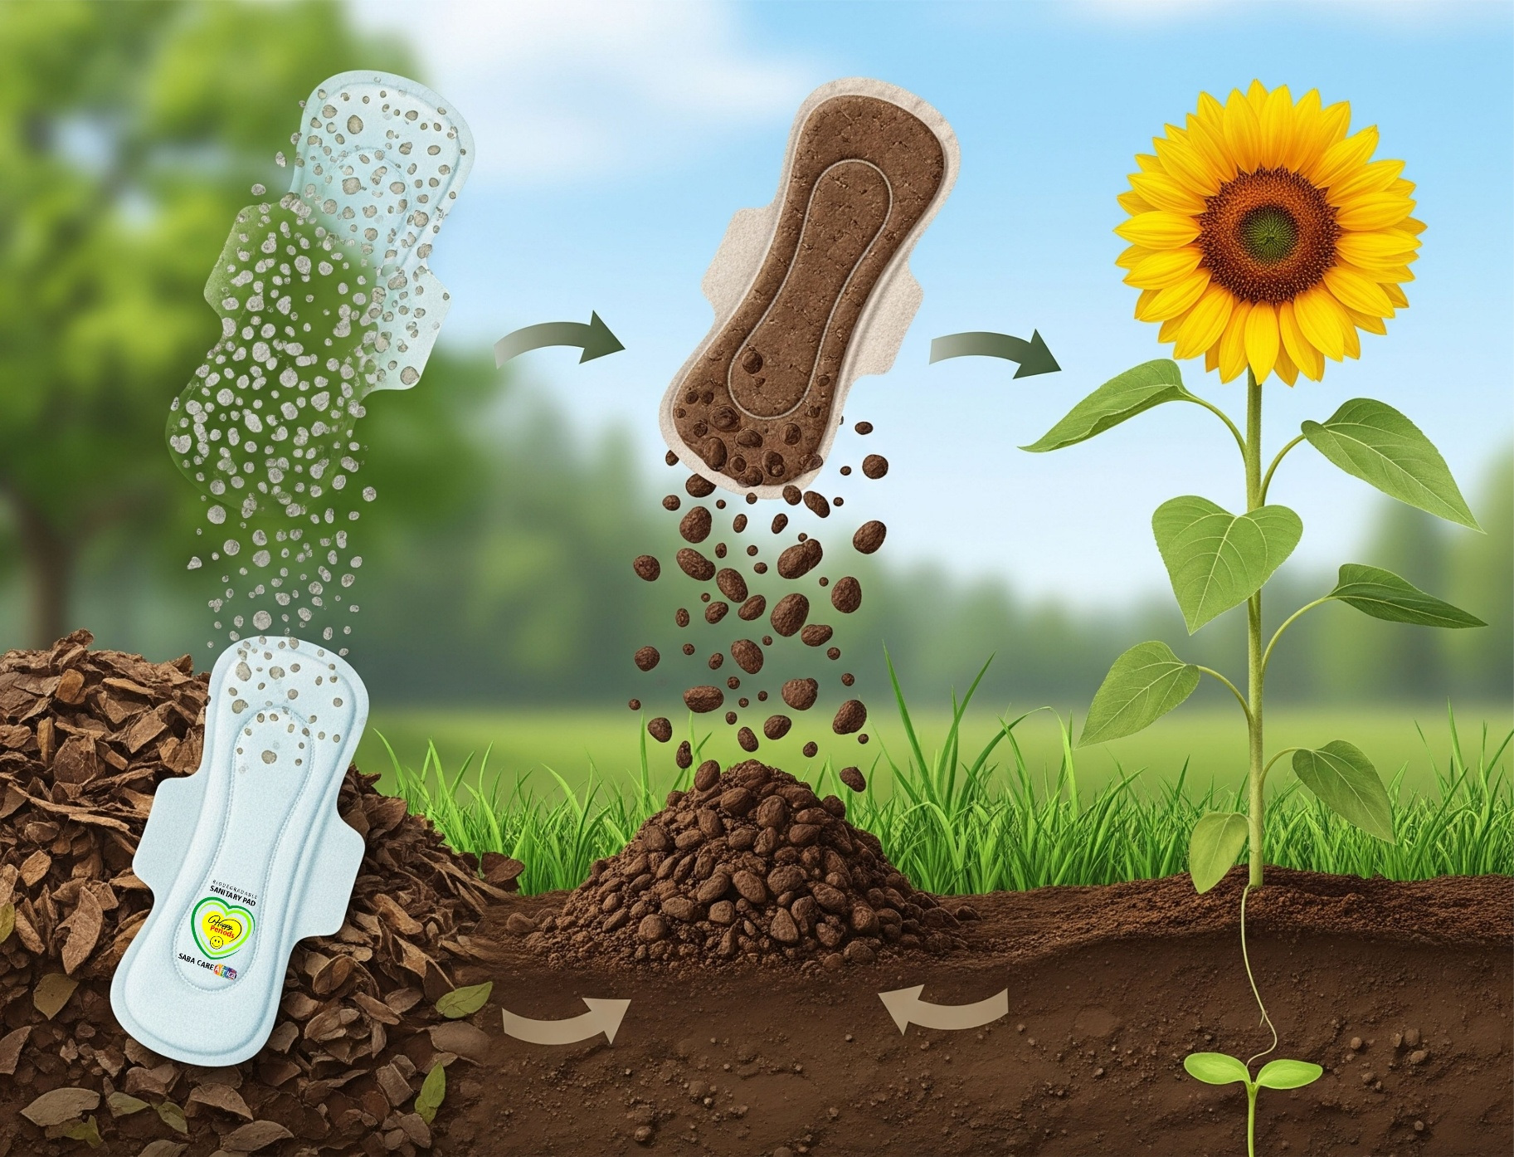**Environmental Benefits:**

**A Promise to Our Planet:**



**Combat Plastic Pollution:** Conventional pads are a major source of plastic waste, taking hundreds of years to decompose, whereas, Bio Pad breaks down completely into natural elements under composting, leaving no harmful residues under composting conditions.

**Completes Nature's Cycle:** One can witness the journey of Bio Pad- from disposal, it disintegrates, biodegrades into nutrient-rich compost, enriches the soil, and ultimately helps new plant life germinate. This truly supports a circular economy!

**Preserving Our Future:** Every Bio Pad chosen is a step towards a cleaner, healthier environment for future generations, protecting our precious ecosystems from synthetic waste.

**Environmental Footprint:**

**True Compostability**-

**From Cycle to Soil:**



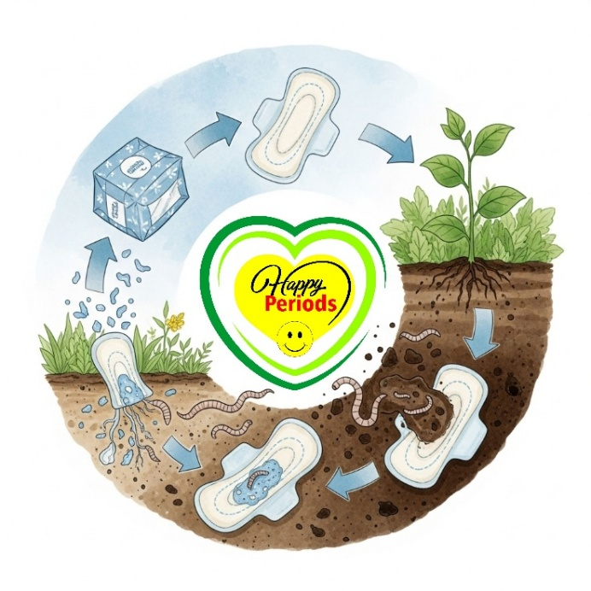**The Journey of a Bio Pad**

**Disposal:** Bio Pad discarded in a compost bin.

**Disintegration:** Pad breaks down into smaller organic particles upon composted.

**Biodegradation:** Microorganisms consume the organic matter.

**Compost Formation:** Rich, nutrient-dense compost is created.

**Soil Enrichment:** Compost enriches soil, improving fertility.

**Plant Germination:** New life sprouts from the enriched soil.







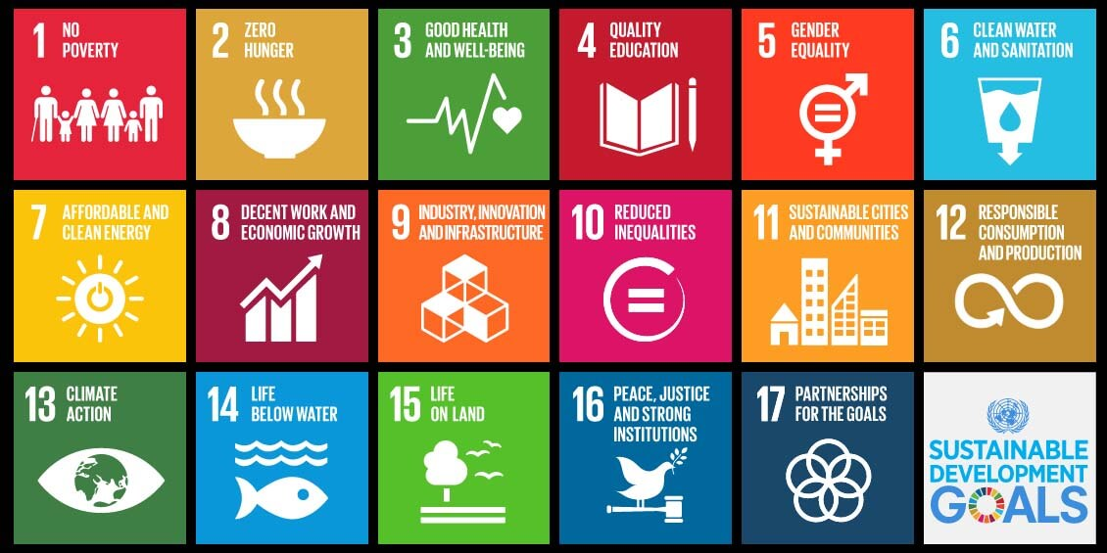

By choosing Saba Care Africa’s Bio Pad, you contribute directly to global efforts in alignment with **UN SDGs**, including:

**SDG 3: Good Health and Well-being:**

* 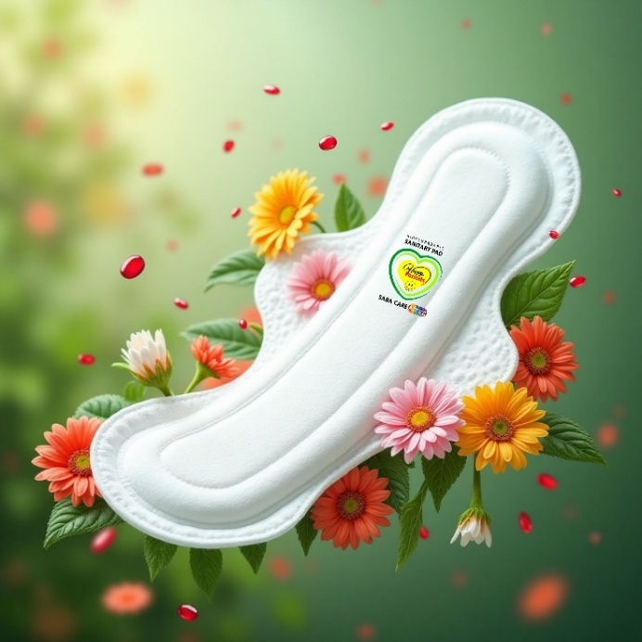Ensuring access to safe and affordable menstrual hygiene products.
* Promoting reproductive health.

**SDG 6: Clean Water and Sanitation:**

* Improving hygiene practices.
* Reducing environmental contamination from menstrual waste.

**SDG 12: Responsible Consumption and Production:**

* Promoting sustainable patterns of consumption and production.
* Minimizing waste generation through prevention, reduction, recycling, and reuse.

**SDG 13: Climate Action:**

* Reducing plastic pollution, a significant contributor to climate change.

**Together, let's empower women**

**and conserve our environment from plastic pollution.**



|  |  |
| --- | --- |
|  | **Choose Happy Periods by**    Contact: +251 907662238, +254 789543818  Email: sabacareafrica@gmail.com |